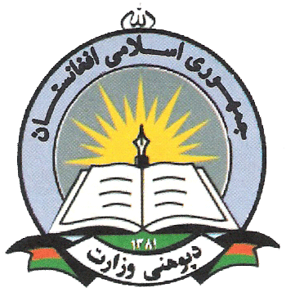

Islamic Republic of Afghanistan
Ministry of Education
National Education Quality Improvement Program (EQUIP)
Afghan Female Youth Employment Initiative (AFYEI)
TOR: Social Mobilization Officer

Post Title:
Social Mobilization Officer
Unit: | Program
Type of Job: | Full Time
Duration: | 36 Months
Duty Station | Mazar-e-Sharif, Balkh Province
Nationality Afghan
Gender: Male / Female

Project Background

The Female Youth Employment Initiative (FYEI) is a joint initiative between the World Bank and the Ministry of Education, Government of Afghanistan. A pilot project, the FYEI aims to address lacunae in the human capital attainments and paid employment opportunities for young women. It is one of several projects in low-income, conflict-affected countries that are part of the Adolescent Girls Initiative (AGI), launched by the World Bank in partnership with Nike Foundation. The pilot will be implemented in Balkh Province.

Main Responsibility of the Social Mobilization Officer

The main responsibility of the Social Mobilization Officer is to mobilize the target communities in Mazar-e-Sharif and select districts of Balkh through the previously established School Management Shuras (SMS) to support and participate in the proper execution of all activities within the scope of the project and in compliance with the guidelines and procedures of the World Bank.
Specific Responsibilities of the Social Mobilization Officer

The Social Mobilization Officer will be responsible for the effective operational implementation of the project and its components by overall mobilization of the communities. He / She will be responsible for regular interactions with SMSs in the target areas and proper mobilization of the communities for the proper implementation of the projects in order to achieve the predicated targets within the allocated time frame. More specifically, the work involves the following responsibilities:

- Provide orientation trainings to SMSs about FYEI objectives and components
- Creating awareness about the roles and responsibilities of SMSs
- Provide training to SMSs on how to mobilize their respective communities for active participation in FYEI
- Conduct regular and need based meetings with School Management Shuras (SMSs) for their motivation in order to cooperate and support the development objectives of the project
- Conduct regular meetings with the communities and PTAs to explain the importance and advantage of the project
- Facilitating PED/DED in lowering girls’ drop-out rates from primary and secondary school, with support from SMSs
- Encourage the female youth in target areas to take advantage of the opportunities presented by the project
- Prepare action plans and monitoring plans for regular field visits
- Regularly monitor and supervise the activities SMSs and of the training providers’ activities for FYEI in the province and ensure quality of training during the project implementation
- Prepare activity and progress reports on daily, weekly and monthly basis
- Coordinate and hold meetings with PEDs, DEDs, SMSs and village leaders for better implementation of the project
- Cooperate with the skills trainings implementing agency for effective implementation of the project. Facilitate in creating relationships with other stakeholders— such as community leaders and relevant persons in the private sector, public sector, NGOs, and other organizations—to identify employers’ needs for female employees and promote demand for training graduates of the FYEI through internship opportunities with prospective employers/firms
- Mobilize and encourage the community leaders to improve community involvement in FYEI
- Establish a project grievance mechanism that is accessible to members of all communities that are targeted by the FYEI.
- Any other task assigned by the Project Manager

Qualification/Skills

- To have Bachelor degree in one of the following subjects: social sciences, sociology.
- To have at least three years of relevant experience in community or other social mobilization.
- Experience in dealing with different public institutions, local authorities, civil society, international and national cooperation agencies and the media.
- To have hands-on experience in computer programs (Word, Excel, & Power Point), internet and e-mail skills.
- Must have proven interpersonal skills
- Ability to set priorities and manage time effectively
- Ability to work both independently and as an effective team member
- Demonstrated abilities to take initiatives, build consensus and make things happen;
- Ability to think and communicate clearly with others, motivate and lead people
- Excellent communication skills: speaking, writing, and listening
- Fluent in written and spoken Dari and Pashto languages and knowledge of English is a plus.

